

*shell programming lab*

aSsignment -5

**SUBMITTED BY: SUBMITTED TO:**

**AYUSH KUMAR JHA Dr. Dhiviya Rose**

**SAP ID - 500086400**

**Enrollment no - R200220083**

**B.C.A -I.O.T.**

**EXPERIMENT – 5**

**TITLE:** Working with expr command

**Activities:**

1. Write a shell script that defines variables like A=10 B=20 C=30 D=2 and perform the following operations:

* Add A & B and store the result in SumAB. Print SumAB.
* Multiply C & D and store the result in MulCD. Print MulCD
* Compare A & D and print the larger value.
* CompareB & C and print the lower value.

Ans.

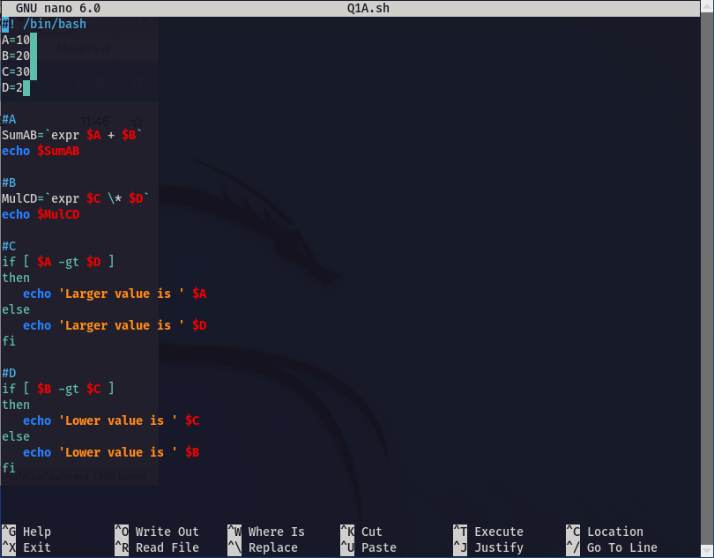

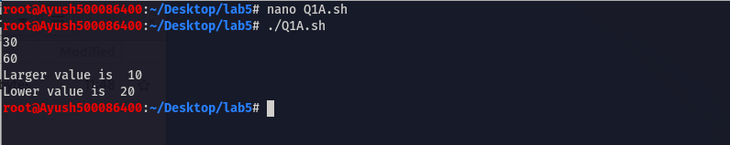

2. Create a menu driven calculator script by getting the input from the user.

Ans.

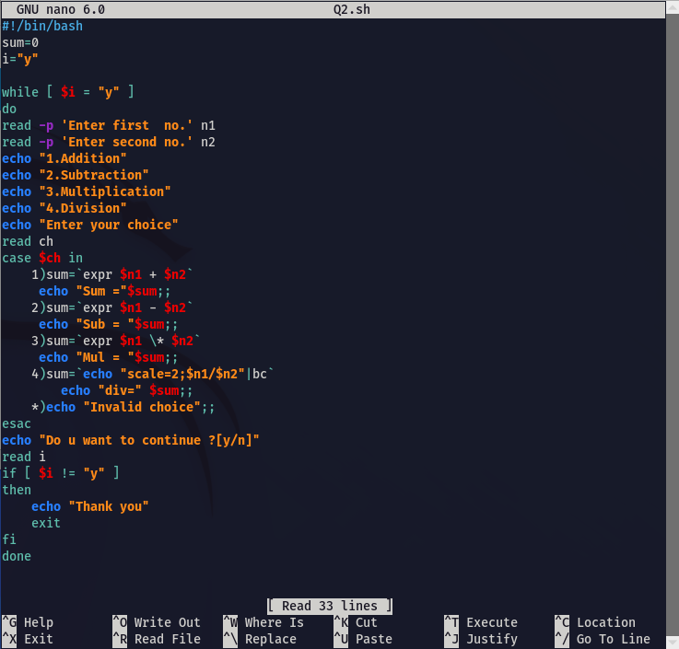

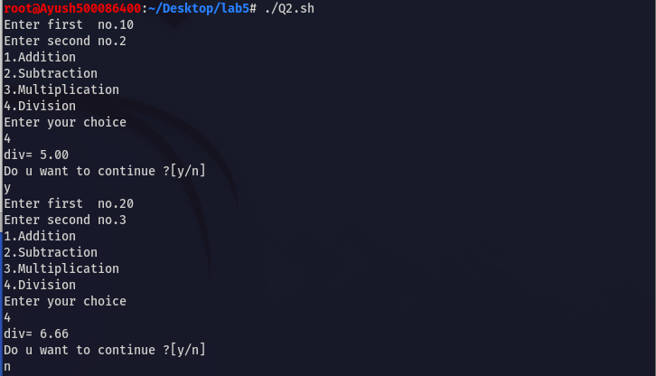

3. List down the rules for creation of variables.

Ans.

The rules of creating the variables are-:

1.The variable name has lower case letters.

2.No dollar sign “$” inserted while printing it.

3.Adding spaces after the initialization of the variable name and its value.

4.Start the variable name with a number, digit, or special symbols

4. Write a program to fetch the command line arguments.

Ans.

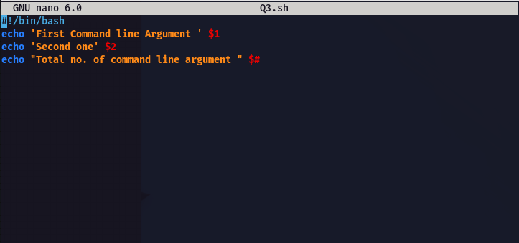

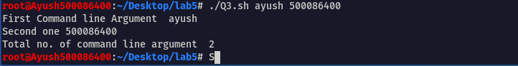

5. Write a program to get user input of 2 numbers , add and display.

Ans.

